**THEORY QUESTIONS ASSIGNMENT**

Software Stream

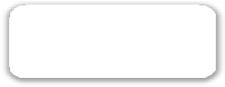

**Maximum score: 100**

KEY NOTES

* This assignment to be completed at student’s own pace and submitted before given deadline.
* There are 10 questions in total and each question is marked on a scale 1 to 10. The maximum possible grade for this assignment is 100 points.
* Students are welcome to use any online or written resources to answer these questions.
* The answers need to be explained clearly and illustrated with relevant examples where necessary. Your examples can include code snippets, diagrams or any other evidence-based representation of your answer.

|  |  |
| --- | --- |
| **Theory questions** | **10 point each** |

1. How does Object Oriented Programming differ from Process Oriented Programming?

All computer programs are conceptually organized around its code and data. This means some programs are written in regards to “what is happening” and “who is being affected”. Both these questions are crucial to how a program is made.

Process oriented programming is an approach that categories a series of linear steps in its code. It is referred to as ‘code acting on data’. It has been successfully used by coding language C. However, it is more problematic to use this approach when the programs grow larger and more complex. To reduce the complexity of Process Oriented Programming, object-oriented programming was created.

Object-oriented programming (OOP) organises a program around its data (objects) and well-defined interfaces to that data. It is often labelled as ‘data controlling access to code’. OOP helps organize complex programs by using inheritance, encapsulation and polymorphism. These 3 concept pillars help the programming environment support the development of far more robust and scalable programs. Encapsulation binds together code and data after it has been manipulated. It keeps both safe from outside interference and misuse.

1. What's polymorphism in OOP?

Polymorphism is the term that shows the meaning of different operations are solely dependent on the object being operated on. For instance, ‘+’ has several meanings:

- in the context of strings, ‘+’ means concatenation

- in the context of integers, ‘+’ means mathematical addition

Polymorphism is particularly useful in python because it shows that code is not constrained to a specific type and can have a generalised meaning.

1. What's inheritance in OOP?

Inheritance is when one object acquires the properties of another object. For example, it uses hierarchical classification. The idea that complex systems can be broken down into more manageable pieces. In an attempt to explain this concept, I’ll use Charles Darwin’s classification of animals in an abstract way. Animals are varied depending on their size, intelligence and type of skeletal system. They also vary based on their feeding, breathing, nocturnal vs diurnal habits. The previous description is the ‘*class*’ definition for animals. However, the ‘*subclass*’ would focus on types of animals with a tail and mammary gland. These animals would be called mammals. Mammals are considered the ‘superclass’. If mammals are considered as animals, they’ll inherit all the attributes from animals. Therefore, an inherited subclass inherits all the attributes from each ancestor in class hierarchy.

Inheritance works well with encapsulation because when a class encapsulates attributes, the subclass will have the same attributes and some more specialization. This stops it from having unpredictable interactions with the rest of the code.

Labrador

-Age

-Sex

-Weight

-Litter Size

-Gestation Period

-Hunting Skills

-Tail length?

-Indoor / Outdoor?

-Leash Trained?

-Duck Hunting Trained

-AKC Certified

-Age

-Sex

-Weight

Animal

-Litter size

-Gestation Period

Mammal

Canine

- Hunting skills

- Tail length

Domesticus

-Leash trained

-Indoor /outdoor

Retriever

Duck hunting trained

AKC Certified

Labrador

1. If you had to make a program that could vote for the top three funniest people in the office, how would you do that? How would you make it possible to vote on those people?
2. Create a voter object for each employee containing the following fields: their employee id, number of votes received in integer, and has_voted Boolean
3. Store each of these voter objects in a dictionary, where the key is the employee id and the value is the voter object above
4. For every employee that wants to vote, he/she enters his/her employee id, use the employee id to fetch the employee's voter object, check if has_voted is false, if true, throw an exception that has already voted
5. Otherwise ask the user to either enter the Employee id he/she is for voting or select from a list of employees
6. After entering the employee id that he/she wants to vote for, set the has_voted field to true in initial voter object in step c.
7. Then use the employee id that was provided in step d to fetch the voter object from the dictionary, increase the number of votes by 1
8. After the vote has ended, sort the dictionary by number of votes in descending order
9. The top 3 people at the top of the dictionary have been voted the funniest people in the office.

1. What's the software development cycle?

The use of standard business practice to construct software applications. This is usually a 6 – 8 step phase: planning, analysis, design, development, testing, implementation, and maintenance.

1. What's the difference between agile and waterfall?

* Unlike waterfall, agile requires less concrete planning, intense commitment as team members are often wearing many hats and the final product can differ.
* Agile is used to build something innovative that doesn’t exist in any form today
* Agile is highly transparent. All team members, stakeholders, product owners and the scrum master knows what is going on at all times, which helps with better quality control over the project
* Agile teams have more autonomy and authority over their decisions.
* Using agile prevents the product delivery from failing
* Agile allows the teams to respond to customer reaction and constant improve the product and focus on the business valve and customer needs
* In Agile, the project is delivered in a short amount of time (new features are delivered quickly and frequently 1-4 weeks)
* Agile teams are allowed flexible work and few initial requirements without the need to meet strict regulations 1. Customer is always involved in the decision-making process, this leads to greater customer engagement. (Improved stakeholder engagement.)
* Agile allows teams to respond to customer reaction and constantly improve the product
* Sprints have a fixed time line. The cost is predictable and limited to the amount of work that can be performed by the team.
* There is an opportunity to constantly refine and reprioritize the overall product backlog
* In waterfall the project budget is fixed and cannot be increased
* In waterfall the organization has strict rules and protocols
* Waterfall is used If the team is delivering an enhancement to an existing legacy product

1. What is a reduced function used for?

The reduced function applies the function your choice to the first 2 elements of an iterable. It repeats the process until only a single cumulative value remains. This function is effective when a programmer processes iterables without the need to write for loops.

import functools

letters = ['H', 'E', 'L', 'L', 'O']

word = functools.reduce(lambda x, y,:x + y, letters)

print(word)

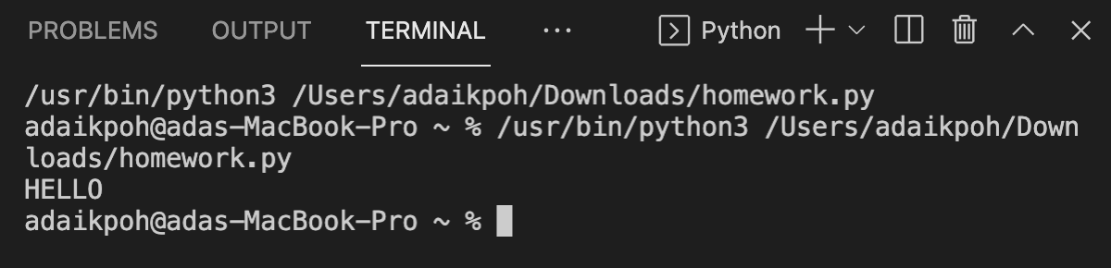

factorial = [120]

result = functools.reduce(lambda x, y,:x + y, factorial)

print(factorial)

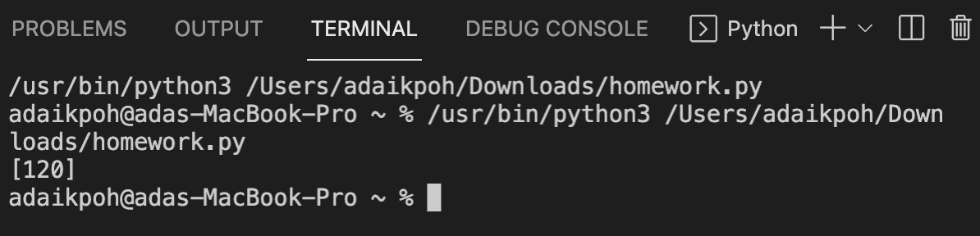

1. How does merge sort work?

Merge sort can be referred to as a divide and concur algorithm. An array is passed as an argument to a merge sort function. This function divides the array into 2. You’ll be left with a left array and a right array (sub-arrays). The elements of the original array will be copied to the two new sub arrays

Merge sort***(52438917)***

**5243**

**8917**

Merge sort is a recursive function. That means at the end of merge sort, it is called again and again and the called sub-arrays are passed in. The merge sort divides the sub arrays and creates 2 new sub- arrays.

Merge sort***(52438917)***

**5243**

**8917**

**52**

**43**

**89**

**17**

**8**

**9**

**1**

**7**

**5**

**24**

**4**

**3**

This stops when the sub arrays only have a size of 1.

With the process of merging and sorting the numbers are re-arranged in order.

**1234**

**5678**

**23**

**45**

**17**

**89**

**8**

**9**

**1**

**7**

**5**

**24**

**4**

**3**

The merge sort algorithm has a runtime complexity of O (n log n). It runs in quasi-linear time along with quick sort and heap sort. When working with large data sets, merge sort is faster than insertion sort, selection sort and bubble sort. On the other hand, the merge sort algorithm uses more space than a bubble sort, selection sort and insertion sort because we need to create new subarrays to store elements. Whereas bubble sort, selection sort and insertion sort can sort in place so they use a constant amount of space to do their sorting unlike with merge sort.

1. Generators - Generator functions allow you to declare a function that behaves like an iterator, i.e. it can be used in a for loop. What is the use case?

The most common use cases are: insurance, retail banking, aerospace, finance and business services.

In insurance, business insights are created with machine learning. In retail banking, the flexible data can be manipulated and transformed. In aerospace, generators are used to meet software system deadlines. In finance, python generator functions are used to mine data and identify cross-sell opportunity. While in business services, it uses API to access financial information.

1. Decorators - A page for useful (or potentially abusive?) decorator ideas. What is the return type of the decorator?

Decorators are used to ensure the code is doing exactly what it’s supposed to do. It explicitly checks the return types in the functions. It does this by a partial modification of the function’s behaviour. In order for the function to be callable, it wraps one function within another.